**Lab 1**

**Name:** Rohit Pai

**Roll No.:** 38

**UID:** 2018130033

**Batch:** C

**Aim**

To study the different types of physical layer wired/wireless connections

**Introduction**

Transmission Medium

A transmission mediumcan be broadly defined as anything that can carry information from a source to a destination. For example, the transmission medium for two people having a dinner conversation is the air. The air can also be used to convey the message in a smoke signal or semaphore. For a written message, the transmission medium might be a mail carrier, a truck, or an airplane.[1]

In data communications, the definition of the information and the transmissionmedium is more specific. The transmission medium is usually free space, metallic cable,or fiber-optic cable. The information is usually a signal that is the result of a conversionof data from another form.[1]

Transmission media are actually located below the physical layer and are directly controlled by the physical layer. Hence, transmission media could be called as the layer zero.[1]

Physical Layer

In the seven-layer OSI model of computer networking, the physical layer or layer 1 is the first and lowest layer.[2]

The physical layer defines the **means of** **transmitting raw bits over a physical data link connecting network nodes**. The bitstream may be grouped into code words or symbols and converted to a physical signal that is transmitted over a transmission medium. The physical layer provides an electrical, mechanical, and procedural interface to the transmission medium. The shapes and properties of the electrical connectors, the frequencies to broadcast on, the line code to use and similar low-level parameters, are specified by the physical layer.[2]

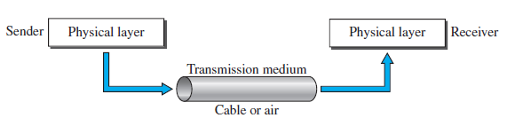

Transmission medium and physical layer [1]

**Types of Transmission Media**

In telecommunications, transmission media are classified as one of the following:

* Guided (or bounded)—waves are guided along a solid medium such as a transmission line. They consist of twisted pair, coaxial cable and optical fibre.[3]
* Wireless (or unguided)—transmission and reception are achieved by means of an antenna. They consist of radio, microwave and infrared transmission.[3]

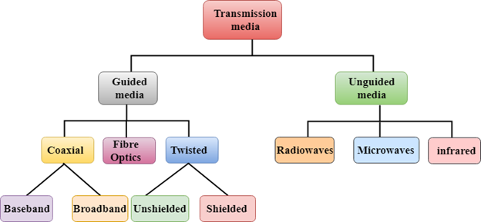

Different Types of Transmission Media [4]

We consider the following factors while selecting a transmission medium: [5]

1. Transmission Rate
2. Cost and Ease of Installation
3. Resistance to Environmental Conditions
4. Distances

**Guided Media**

**Guided media,** which are those that provide a conduit from one device to another, include **twisted-pair cable, coaxial cable,** and **fiber-optic cable.** A signal traveling along any of these media is directed and contained by the physical limits of the medium. [1]

Twisted-pair and coaxial cable use metallic (copper) conductors that accept and transport signals in the form of electric current. [1]

**Optical fiber** is a cable that accepts and transports signals in the form of light. [1]

The different types of guided media are described in detail as follows:

1) Twisted Pair Cable

Twisted-pair is one of the oldest and still the most common transmission media of cabling that is used for telephone communications and most modern Ethernet networks.[6]

A twisted pair consists of two conductors (normally copper), each with its own plastic insulation, twisted together, as shown below. [1]



Twisted-pair cable [1]

One of the wires is used to carry signals to the receiver, and the other is used only as a ground reference. The receiver uses the difference between the two. In addition to the signal sent by the sender on one of the wires, interference (noise) and crosstalk may affect both wires and create unwanted signals. [1]

If the two wires are parallel, the effect of these unwanted signals is not the same in both wires because they are at different locations relative to the noise or crosstalk sources (e.g., one is closer and the other is farther). This results in a difference at the receiver. [1]

By twisting the pairs, a balance is maintained. For example, suppose in one twist, one wire is closer to the noise source and the other is farther; in the next twist, the reverse is true. Twisting makes it probable that both wires are equally affected by external influences (noise or crosstalk). This means that the receiver, which calculates the difference between the two, receives no unwanted signals. The unwanted signals are mostly cancelled out. It is clear from the above statements that the number of twists per unit of length (e.g., inch) has some effect on the quality of the cable. [1]

Some specifications for twisted pair cables: [7]

* Its frequency range is 0 to 3.5 kHz.
* Typical attenuation is 0.2 dB/Km @ 1kHz.
* Typical delay is 50 µs/km.
* Repeater spacing is 2km.

There are two types of twisted pair cables – ***unshielded twisted-pair (UTP)***, which is the most common twisted-pair cable used in communications, and ***shielded twisted-pair* (STP).**

a) Unshielded Twisted-pair

UTP cable is a medium that is composed of pairs of wires (Refer to below diagram).UTP cable is used in a variety of networks. Each of the eight individual copper wires in UTP cable is covered by an insulating material. In addition, the wires in each pair are twisted around each other. [8]

UTP cable relies solely on the cancellation effect produced by the twisted wire pairs to limit signal degradation caused by electromagnetic interference (EMI) and radio frequency interference (RFI). To further reduce crosstalk between the pairs in UTP cable, the number of twists in the wire pairs varies. UTP cable must follow precise specifications governing how many twists or braids are permitted per meter (3.28 feet) of cable. [8]

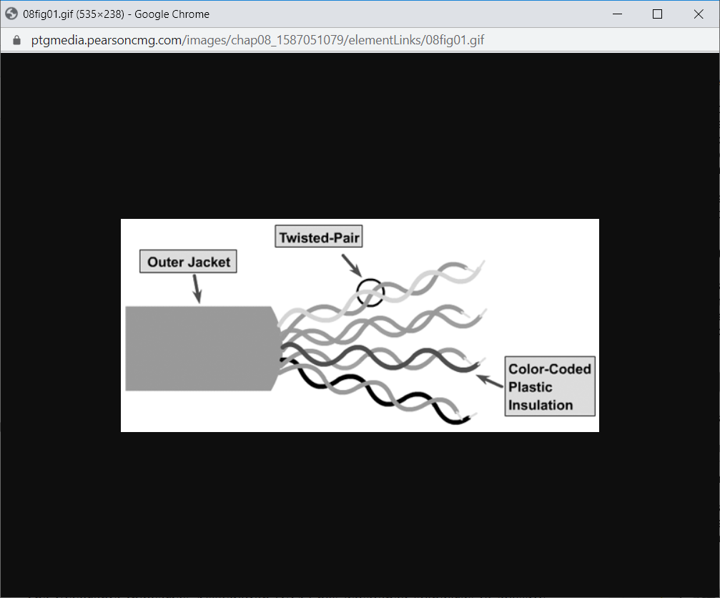

Unshielded Twisted-pair [8]

UTP cable is easy to install and is less expensive than other types of networking media. In fact, UTP costs less per meter than any other type of LAN cabling. And because UTP can be used with most of the major networking architectures, it continues to grow in popularity.

Disadvantages also are involved in using twisted-pair cabling, however. UTP cable is more prone to electrical noise and interference than other types of networking media, and the distance between signal boosts is shorter for UTP than it is for coaxial and fiber-optic cables.

Specifications [8]

1. The cable has 4 pairs of either 22- or 24- gauge copper wire when used as a networking medium
2. It has an external diameter of approximately 0.43 cm (0.17 inches) which is advantageous during installation.
3. Speed and throughput – 100 to 1000 Mbps
4. Bandwidth – 16 MHz (Cat 3) to 500 MHz (Cat 6) [10]
5. Average cost per node – Least Expensive
6. Media and connector size – Small
7. Maximum cable length – 100 m (short)
8. Impedance – 100 ohms (which is much less than the other types of twisted-pair wiring such as that used for telephone wiring, which has impedance of 600 ohms)

Scalability

Twisted-pair cables are used in telephone lines to provide voice and data channels. The local loop — the line that connects subscribers to the central telephone office — commonly consists of unshielded twisted-pair cables. [1]

The DSL lines that are used by the telephone companies to provide high-data-rate connections also use the high-bandwidth capability of unshielded twisted-pair cables. [1]

UTP cables have a maximum cable length of 100m so they are typically in Ethernet as LANs. [7]

Schematic View of Physical Connector

The most common UTP connector is **Registered Jack 45 (RJ-45)**, as shown in the figure below. [1] The RJ45 is a eight-wire, keyed connector, meaning the connector can be inserted in only one way. [1]

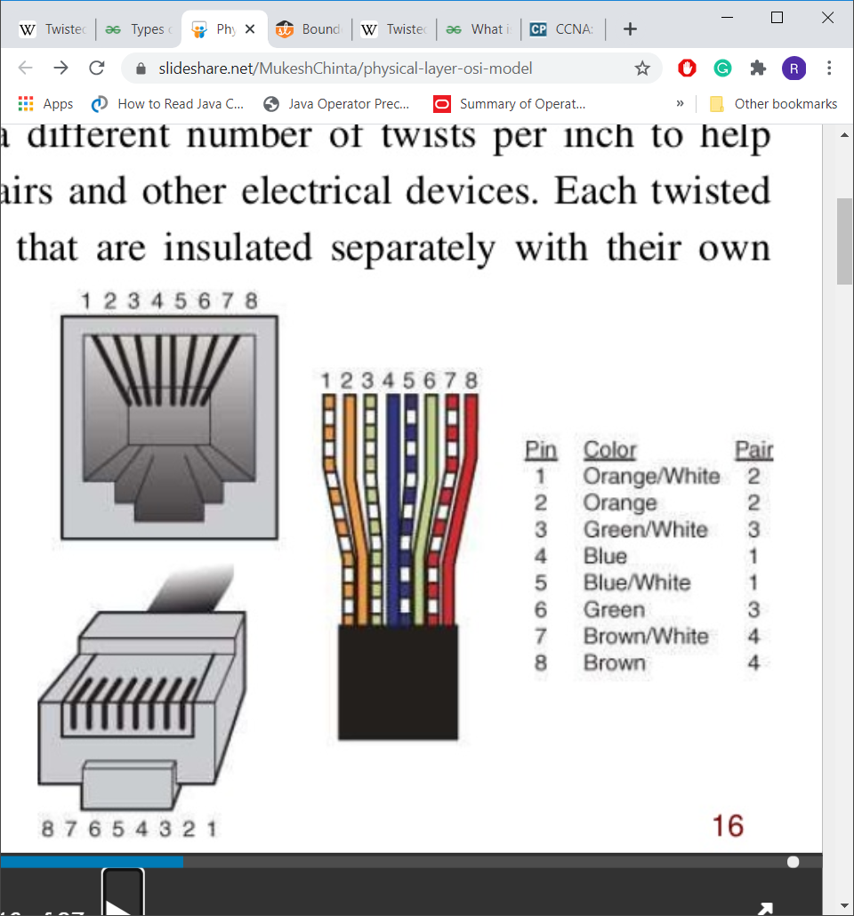

Schematic Diagram of RJ45 Connector with colour coded UTP wires [6]

b) Shielded Twisted-pair

*Shielded twisted-pair (STP)* cable combines the techniques of shielding, cancellation, and wire twisting. Each pair of wires is wrapped in a metallic foil (see figure below). The four pairs of wires then are wrapped in an overall metallic braid or foil, usually 150-ohm cable. [8]

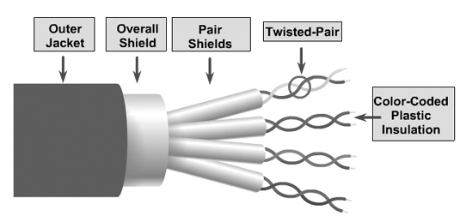

Shielded Twisted-pair [8]

As specified for use in Ethernet network installations, STP reduces electrical noise both within the cable (pair-to-pair coupling, or crosstalk) and from outside the cable (EMI and RFI). [8]

Although STP prevents interference better than UTP, it is more expensive and difficult to install. In addition, the metallic shielding must be grounded at both ends. If it is improperly grounded, the shield acts like an antenna and picks up unwanted signals.

Specifications

1. Speed and throughput—10 to 100 Mbps
2. Bandwidth – 100 MHz (Cat 5e) to 2000 MHz (Cat 8.2)
3. Average cost per node—Moderately expensive
4. Media and connector size—Medium to large
5. Maximum cable length—100 m (short)
6. Impedance – 150 ohms

Scalability

Similar to UTP, STP also has a maximum cable length of 100 m so it is typically used in Ethernets as LANs.

Schematic View of Physical Connector

STP usually is installed with STP data connector, which is created especially for the STP cable [8] (DIN-type connector used by AppleTalk and IBM Data Connecter used by IBM [9]). However, STP cabling also can use the same RJ connectors that UTP uses [8] (shown above in UTP).

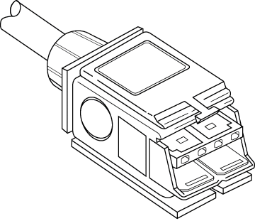

Connectors used with STP Cable

2) Coaxial Cable

Coaxial cable (or *coax*) carries signals of higher frequency ranges than those in twisted-pair cable, in part because the two media are constructed quite differently. Instead of

having two wires, coax has a central core conductor of solid or stranded wire (usually

copper) enclosed in an insulating sheath, which is, in turn, encased in an outer conductor

of metal foil, braid, or a combination of the two. The outer metallic wrapping serves

both as a shield against noise and as the second conductor, which completes the circuit.

This outer conductor is also enclosed in an insulating sheath, and the whole cable is

protected by a plastic cover (see the figure below) [1].

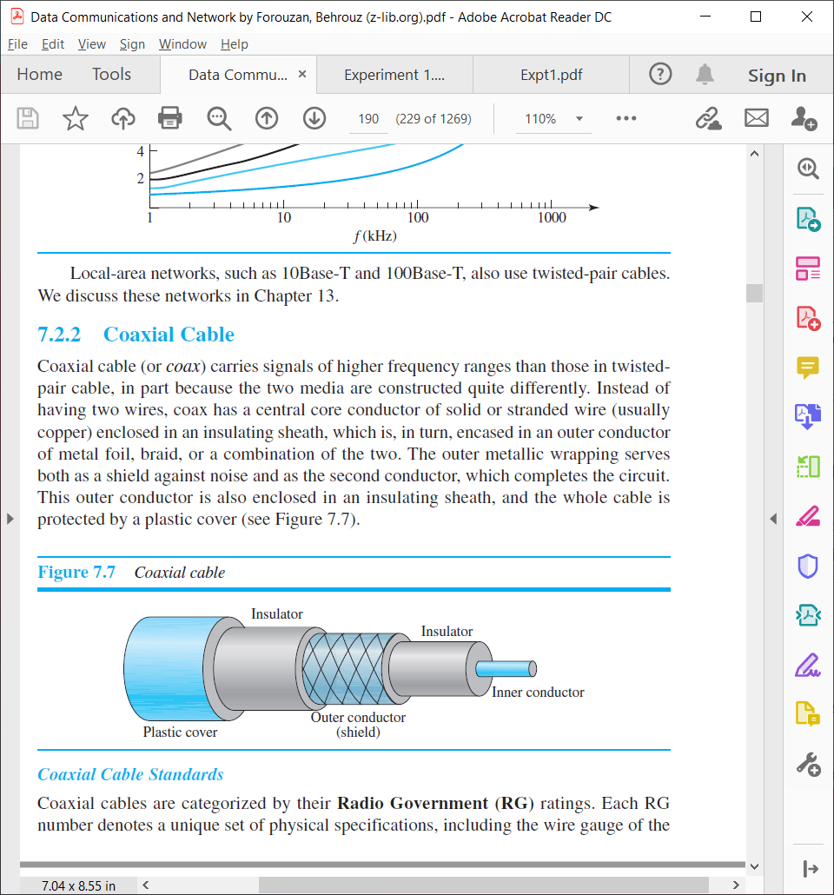

Coaxial Cable [1]

Specifications

Coaxial cables are categorized by their **Radio Government (RG)** ratings. Each RG

number denotes a unique set of physical specifications, including the wire gauge of the

inner conductor, the thickness and type of the inner insulator, the construction of the

shield, and the size and type of the outer casing. Each cable defined by an RG rating is

adapted for a specialized function, as shown in the table below. [1]

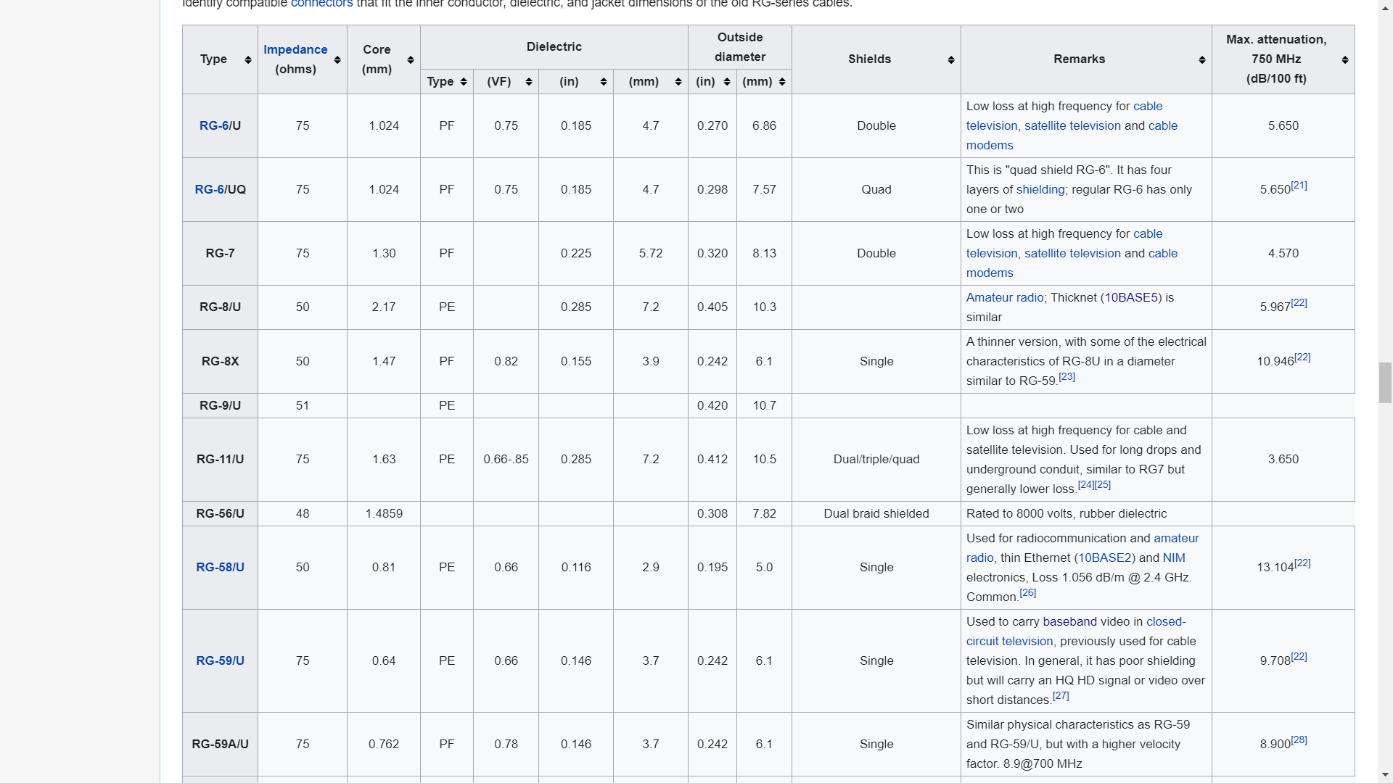

The most common coaxial cable standards [11]

Scalability

Coaxial cable was widely used in analog telephone networks where a single coaxial network could carry 10,000 voice signals. Later it was used in digital telephone networks where a single coaxial cable could carry digital data up to 600 Mbps. However, coaxial cable in telephone networks has largely been replaced today with fibre-optic cable. [1]

Cable TV networks also use coaxial cables. In the traditional cable TV network (an example of MAN), the entire network used coaxial cable. Later, however, cable TV providers replaced most of the media with fibre-optic cable; hybrid networks use coaxial cable only at the network boundaries, near the consumer premises. Cable TV uses RG-59 coaxial cable. [1]

Another common application of coaxial cable is in traditional Ethernet LANs. Because of its high bandwidth, and consequently high data rate, coaxial cable was chosen for digital transmission in early Ethernet LANs. The 10Base-2, or Thin Ethernet, uses RG-58 coaxial cable with BNC connectors to transmit data at 10 Mbps with a range of 185 m. The 10Base5, or Thick Ethernet, uses RG-11 (thick coaxial cable) to transmit 10 Mbps with a range of 5000 m. Thick Ethernet has specialized connectors.[1]

Schematic View of Physical Connector

To connect coaxial cable to devices, we need coaxial connectors. The most common type of connector used today is the **Bayonet Neill-Concelman (BNC)** connector. The figure below shows three popular types of these connectors: the BNC connector, the BNC T connector, and the BNC terminator. [1]

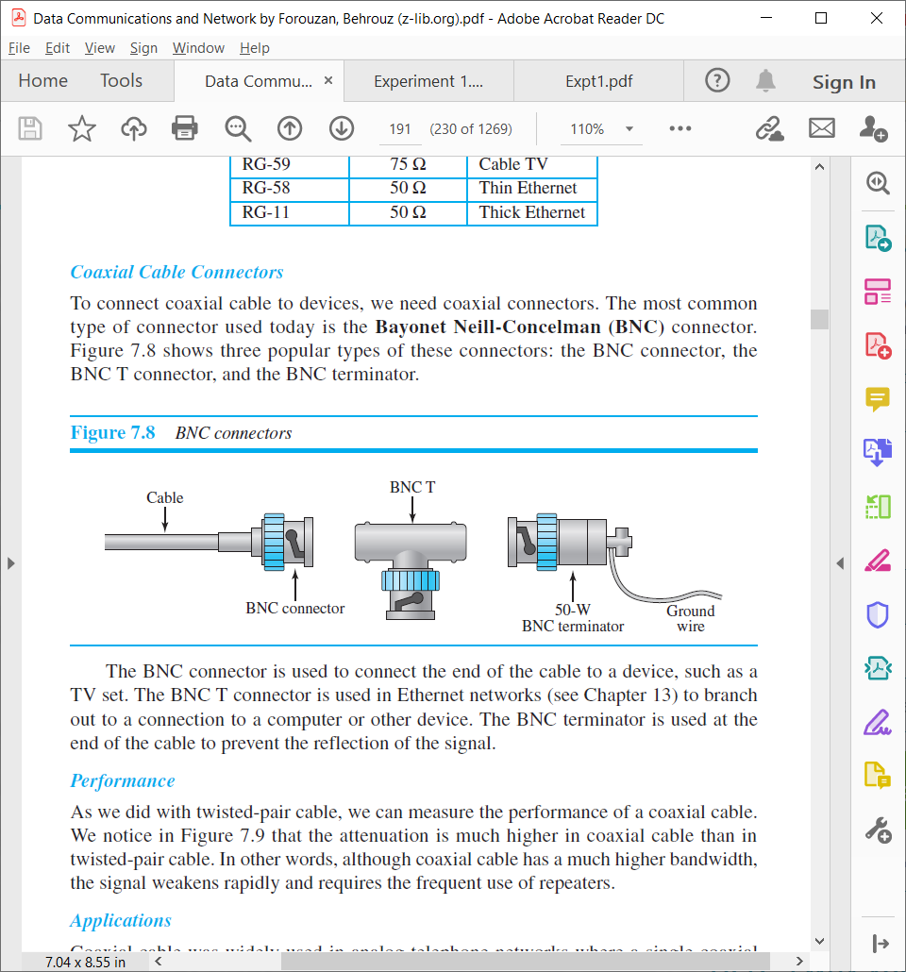

Overview of BNC Connectors [1]

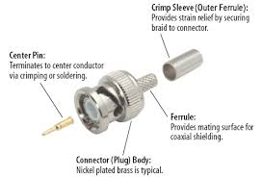

BNC Connector [12]

The BNC connector is used to connect the end of the cable to a device, such as a TV set. The BNC T connector is used in Ethernet networks to branch out to a connection to a computer or other device. The BNC terminator is used at the end of the cable to prevent the reflection of the signal. [1]

3) Optical Fibre Cable  
Fibre Optics is the communications medium that works by sending optical signals down hair-thin strands of extremely pure glass or plastic fibre. The light is "guided" down the centre of the fibre called the "core". The core is surrounded by an optical material called the "cladding" that traps the light in the core using an optical technique called "total internal reflection."  The fibre itself is coated by a "buffer" as it is made to protect the fibre from moisture and physical damage. The buffer is what one strips off the fibre for termination or splicing. [13]

The core and cladding of most fibres are made of ultra-pure glass, although some fibres are all plastic or a glass core and plastic cladding. The core is designed to have a higher index of refraction, an optical parameter that is a measure of the speed of light in the material, than the cladding, which causes  "total internal reflection" to trap light in the core up to a certain angle, which defines the “numerical aperture” of the fibre. [13]

Glass fibre is coated with a protective plastic covering called the "primary buffer coating" that protects it from moisture and other damage. More protection is provided by the "cable" which has the fibres and strength members inside an outer protective covering called a "jacket". [13]

Types of Fibres: Multimode & Single-mode, Core/Cladding Size

The two types of fibre are multimode and single-mode. Within these categories, fibres are identified by their core composition (MM step-index or graded-index) and core/cladding diameters expressed in microns (one millionth of a meter), e.g. 50/125 micron graded-index multimode fibre. Most glass fibres are 125 microns in outside diameter - a micron is one one-millionth of a meter and 125 microns is 0.005 inches- a bit larger than the typical human hair. [13]

Multimode fibre has light traveling in the core in many rays, called modes. It has a larger core (almost always 50 or 62.5 microns) which supports the transmission of multiple modes (rays) of light.  Multimode is generally used with LED sources at wavelengths of 850 and 1300 nm for slower local area networks (LANs) and lasers at 850 (VCSELs) and 1310 nm (Fabry-Perot lasers) for networks running at gigabits per second or more. [13]

Single-mode fibre has a much smaller core, only about 9 microns, so that the light travels in only one ray (mode.) It is used for telephony and CATV with laser sources at 1310 and 1550 nm because it has lower loss and virtually infinite bandwidth. [13]

Construction

The figure below shows the composition of a typical fibre-optic cable. [1]

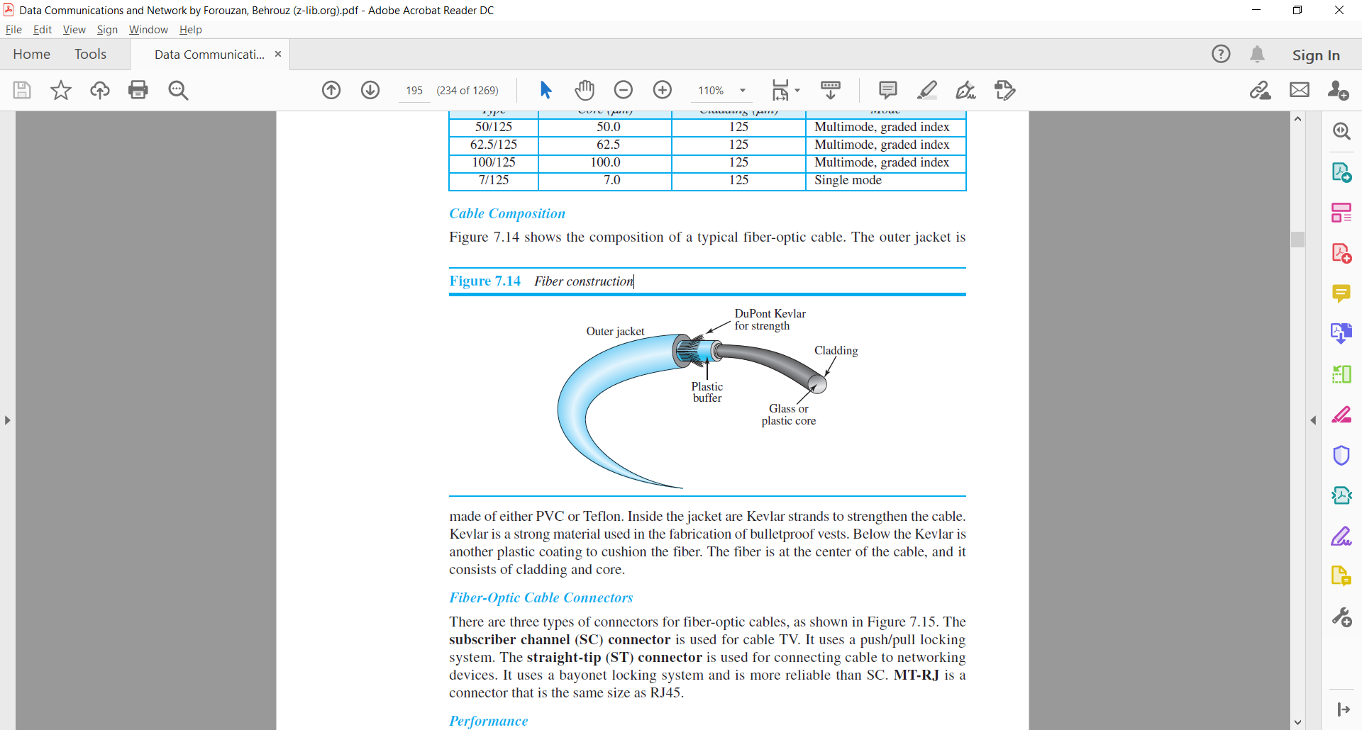

Fibre construction [1]

The outer jacket is made of either PVC or Teflon. Inside the jacket are Kevlar strands to strengthen the cable. Kevlar is a strong material used in the fabrication of bulletproof vests. Below the Kevlar is another plastic coating to cushion the fiber. The fiber is at the center of the cable, and it consists of cladding and core. [1]

Sizes

Optical fibers are defined by the ratio of the diameter of their core to the diameter of their cladding, both expressed in micrometers. The common sizes are shown in the table below. [1]

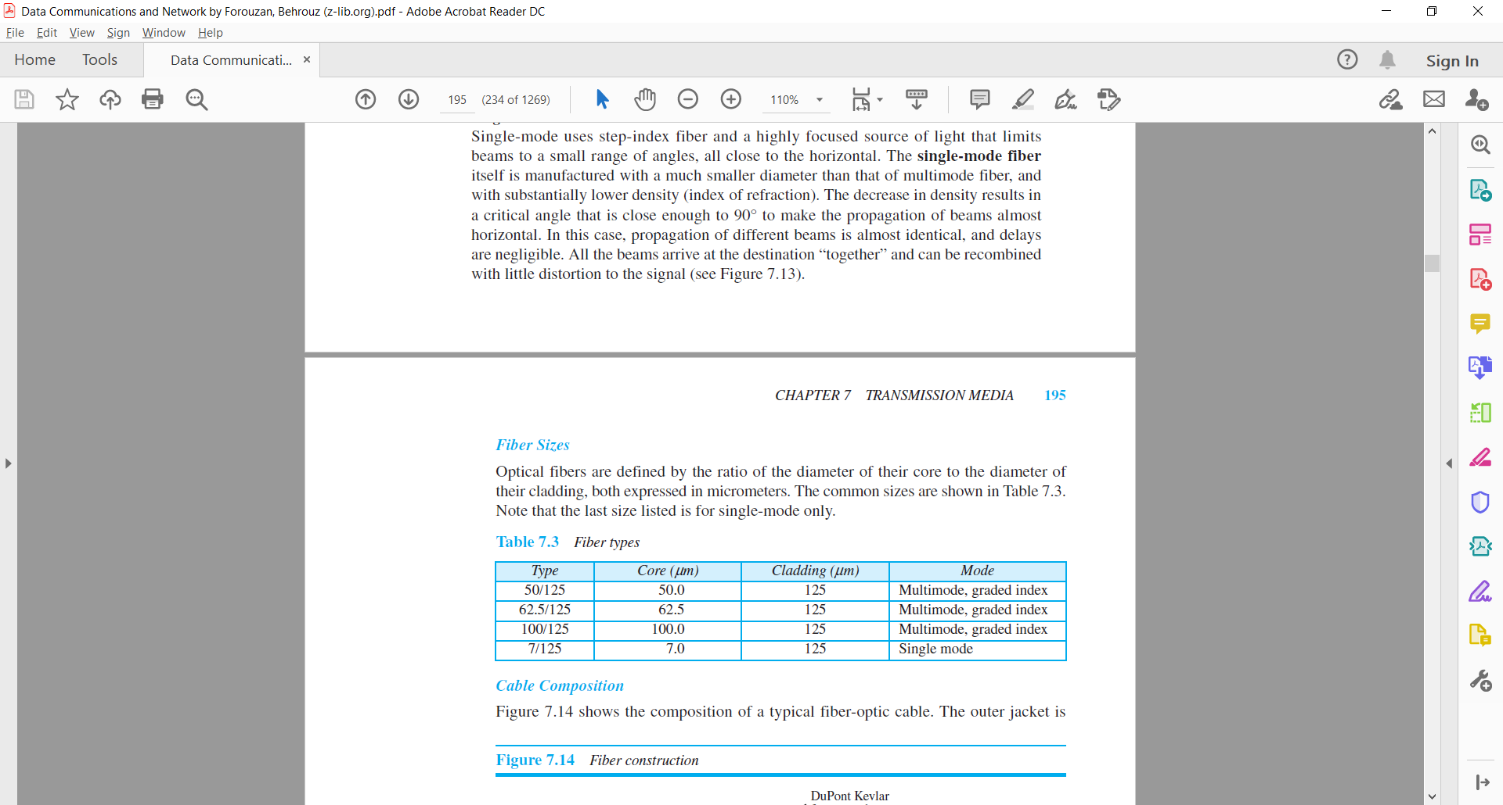

Fibre Sizes [1]

Specifications

These are the specifications of the different standards of fibre-optic cables [13]-

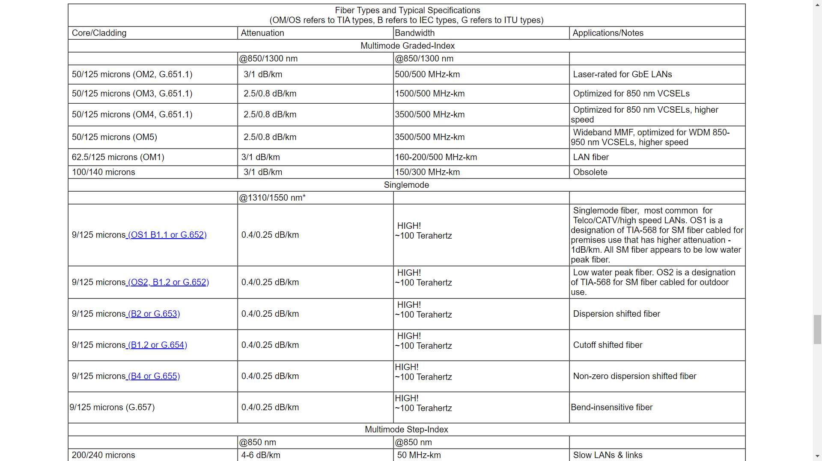

Scalability

Fibre optic cables are very versatile and can be used in LANs for home use and MANs for cable television too. Fibre optics are much more scalable meaning that new equipment can easily be laid over the original fibre, with wavelengths turned on and off to allow for quick scaling if needed. Spare fibre optics can be included for future use and additional cables also laid at a later stage. [14]

Schematic View of Physical Connectors

There are three types of connectors for fiber-optic cables, as shown in figure below. The **subscriber channel (SC) connector** is used for cable TV. It uses a push/pull locking system. The **straight-tip (ST) connector** is used for connecting cable to networking devices. It uses a bayonet locking system and is more reliable than SC. **MT-RJ** is a connector that is the same size as RJ45. [1]

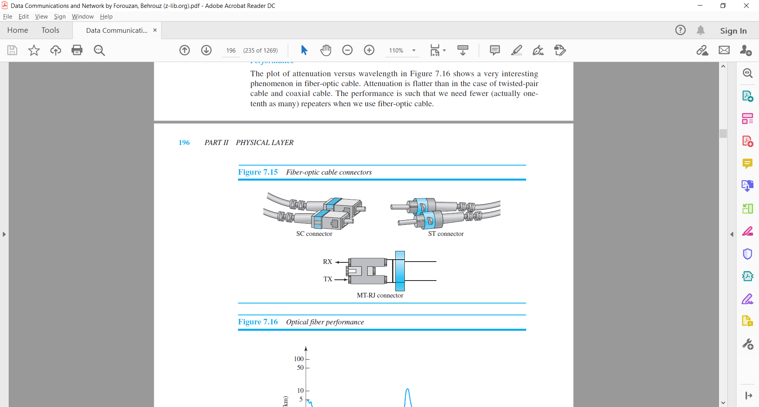

Fiber-optic cable connectors [1]

**Types of Physical Layer Interfaces**

There are mainly 2 types of physical layer interfaces: Wired and Wireless

**Wired Physical Layer Interfaces**

A wired network connection is described as a configuration that involves cables which establish a connection to the Internet and other devices on the network. Most wired networks use Ethernet cables to transfer data between connected PCs. In a small wired network, a single router may be used to connect all the computers. Larger networks often involve multiple routers or switches that connect to each other. [19]

**1) Fibre Distributed Data Interface (FDDI)**

Fibre Distributed Data Interface (FDDI) is a set of ANSI and ISO standards for transmission of data in local area network (LAN) over fibre optic cables. FDDI uses optical fibre as its physical medium. It operates in the physical and medium access control (MAC layer) of the Open Systems Interconnection (OSI) network model. [15]

Specifications [16]

* Transmission rate: 125 megabaud (100 Mb/s at the data link)
* Physical layer entities: 1000 (max)
* Total Ring length: 200 km (124 mi) (max)
* Transmission medium: Fibre optic or copper cable
* Network topology: Dual ring of trees
* Media access method: Timed-token passing

Modulation Scheme (Line Coding)

Uses nonreturn to zero inverted (NRZI) with 4b/5b encoding

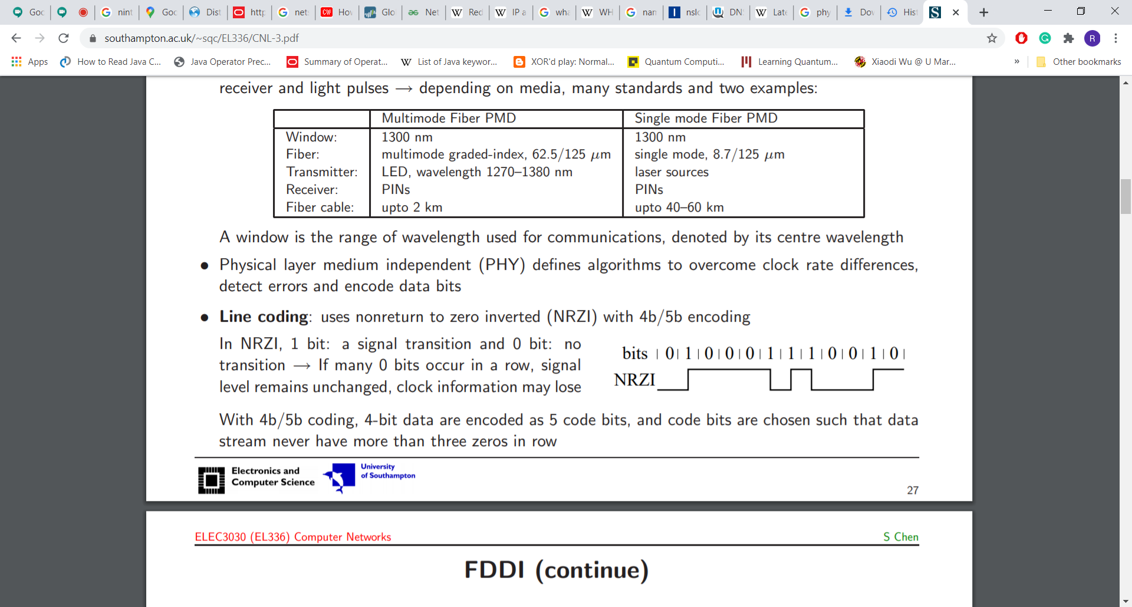

In NRZI, 1 bit: a signal transition and 0 bit: no transition → If many 0 bits occur in a row, signal level remains unchanged, clock information may lose bits. With 4b/5b coding, 4-bit data are encoded as 5 code bits, and code bits are chosen such that data stream never have more than three zeros in row. [17]

Scalability

Fibre Distributed Data Interface (FDDI) is usually implemented as a dual token-passing ring within a ring topology (for campus networks) or star topology (within a building). [18]

It is applicable in large LANs that can extend up to 200 kilometres in diameter. Designers normally constructed FDDI rings in a network topology such as a "dual ring of trees". A small number of devices, typically infrastructure devices such as routers and concentrators rather than host computers, were "dual-attached" to both rings. Host computers then connect as single-attached devices to the routers or concentrators. The dual ring in its most degenerate form simply collapses into a single device. [18]

For these reasons, FDDI is not often used as a wide area network (WAN) solution, but

is more often implemented in campus-wide networks as a network backbone.

Typically, a computer-room contained the whole dual ring, although some

implementations deployed FDDI as a metropolitan area network. [18]

Schematic View of the Interface

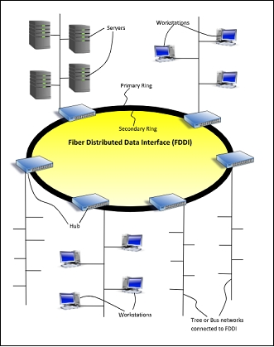

**2) Ethernet**

Ethernet is a system for connecting a number of computer systems to form a local area network, with protocols to control the passing of information and to avoid simultaneous transmission by two or more systems. [39]

Specifications

There are different Ethernet standards. 3 popular standards with their specifications are shown below:

1) 10Base2:

These coaxial cables are like those used in television, but thinner. They are also called "thinnet" or "coax". Each computer has a "T" plugged into it, and cables plug into each side of the "T". Sometimes, instead of a "T", a vampire tap is used. It supports 10MBits per second transfer speed. 10BASE2 coax cables have a maximum length of 185 metres (607 ft). The maximum practical number of nodes that can be connected to a 10BASE2 segment is limited to 30 with a minimum distance of 50 centimetres (20 in) between devices. [19]

2) 10BaseT:

Cables look like thick phone cables, but with 8 copper wires instead of 2 or 4, and they go from each computer' to a Hub or a Switch. Supported speed is 10 MBit/second. 10BASET have a maximum length of 100m and uses twisted pair of wires. Up to 1024 stations can be connected to it and it offers a bandwidth of 10 Mbit/s. [19]

3) 10Base5

10BASE5 uses a thick and stiff coaxial cable up to 500 meters (1,600 ft) in length. Up to 100 stations can be connected to the cable using vampire taps and share a single collision domain with 10 Mbit/s of bandwidth shared among them. [19]

Encoding

Manchester encoding is an encoding method commonly used on Legacy Ethernet networks.

There are two rules to follow using this encoding method:

1. To send a logic '0' data bit, **increase** the voltage up from 0 to +V in the middle of the bit period. [21]
2. To send a logic '1' data bit, **decrease** the voltage down from +V to 0 in the middle of the bit period. [21]

The diagram below illustrates this:-

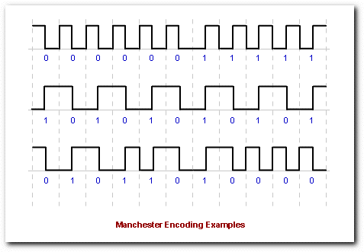

We can see that a high-to-low transistion represents a logic ‘0’ data bit and a low-to-high transistion represents a logic ‘1’ data bit. [21]

Scalability

Ethernet is a family of computer networking technologies commonly used in local area networks (LAN), metropolitan area networks (MAN) and wide area networks (WAN).

Ethernet is currently the most widely used technology in enterprise networking. Unfortunately, Ethernet exhibits scalability issues when used to build broadcast domains of more than a few thousand devices, such as costly and energy-dense address table logic and storms of broadcast traffic. The traditional method of avoiding such problems is the artificial subdivision of a network, but this introduces an administrative burden, requires significant routing equipment and with current protocols also precludes live migration. [20]

Schematic View

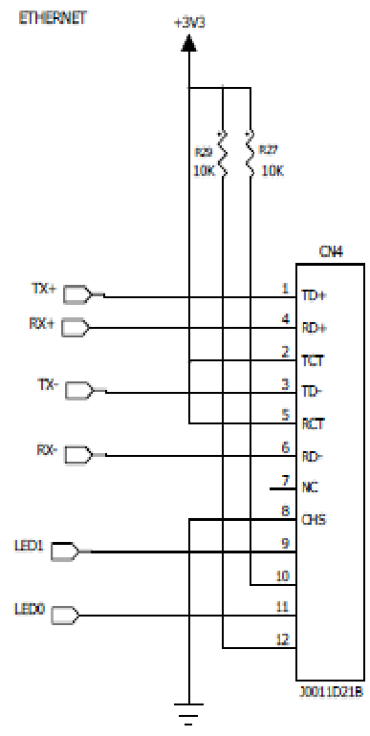

**3) USB**

**Universal Serial Bus** (**USB**) is an industry standard that establishes specifications for cables and connectors and protocols for connection, communication and power supply (interfacing) between computers, peripherals and other computers. A broad variety of USB hardware exists, including several different connectors, of which USB-C is the most recent. [48]

Released in 1996, the USB standard is currently maintained by the USB Implementers Forum (USB-IF). There have been four generations of USB specifications: USB 1.x, USB 2.0, USB 3.x and USB4. [48]

Specifications

Modulation and encoding:

The SuperSpeed bus (USB 3.0) 8b/10b encoding is used where each byte needs 10 bits to transmit, so the raw throughput is 500 MB/s. This also meant that normal data bytes were represented by 10 bits, and this caused a 20% overhead. [50]

SuperSpeed Plus (USB 3.1 and USB 3.2) offers a new encoding scheme called 128b/132b. Thus 128 bits that are represented by 132 bits on the line. This results in only a 3% bandwidth overhead. [50]

Speed:

* Released in January 1996, USB 1.0 specified data rates of 1.5 Mbit/s (Low Bandwidth or Low Speed) and 12 Mbit/s (Full Speed). [50]
* USB 2.0 was released in April 2000, adding a higher maximum signalling rate of 480 Mbit/s (60 MB/s) named High Speed or High Bandwidth. [50]
* USB 3.0 specification was released on 12 November 2008, USB 3.0 adds a SuperSpeed transfer mode, with associated backward compatible plugs, receptacles, and cables. [50]

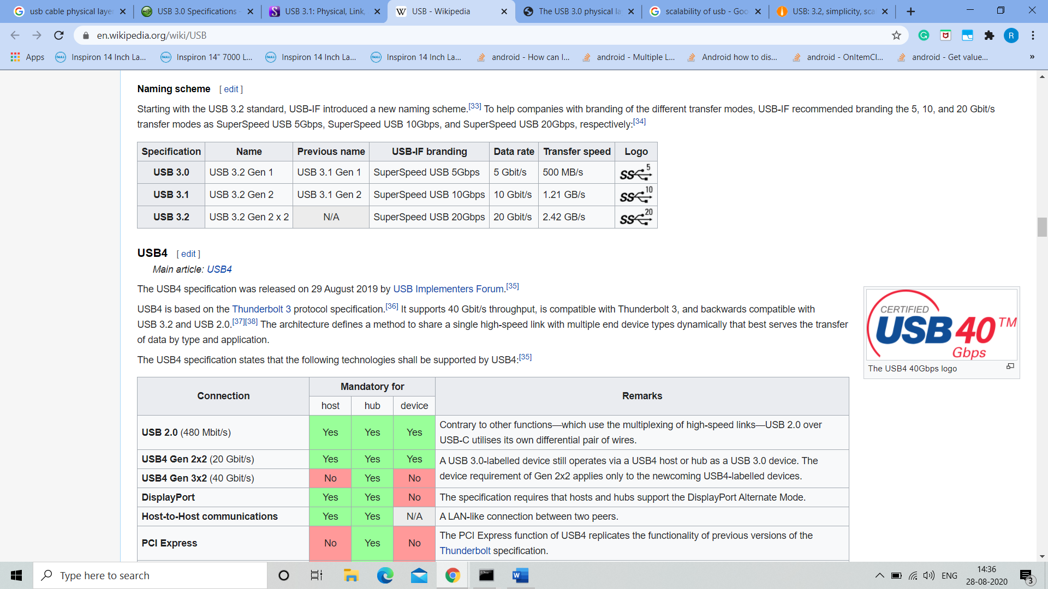

* The USB4 specification was released on 29 August 2019 by USB Implementers Forum. [50]

USB4 is based on the Thunderbolt 3 protocol specification. It supports 40 Gbit/s throughput, is compatible with Thunderbolt 3, and backwards compatible with USB 3.2 and USB 2.0. [50]

Scalability:

 USB possesses multiple limitations to its design:

* USB cables are limited in length, as the standard was intended for peripherals on the same table-top, not between rooms or buildings. However, a USB port can be connected to a gateway that accesses distant devices. [49]
* USB has a strict tree network topology and master/slave protocol for addressing peripheral devices; those devices cannot interact with one another except via the host, and two hosts cannot communicate over their USB ports directly. Some extension to this limitation is possible through USB On-The-Go. [49]
* A host cannot broadcast signals to all peripherals at once—each must be addressed individually. Some very high-speed peripheral devices require sustained speeds not available in the USB standard. [49]
* While converters exist between certain legacy interfaces and USB, they may not provide full implementation of the legacy hardware. For example, a USB-to-parallel-port converter may work well with a printer, but not with a scanner that requires bi-directional use of the data pins. [49]

Schematic view:

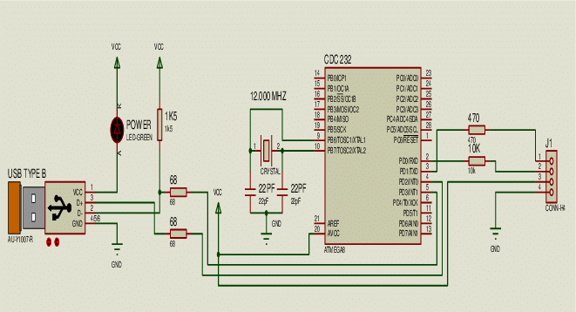

**Wireless Physical Layer Interfaces**

Wireless network is a computer network that uses wireless data connections between network nodes. [40]

Wireless networking is a method by which homes, telecommunications networks and business installations avoid the costly process of introducing cables into a building, or as a connection between various equipment locations admin telecommunications networks are generally implemented and administered using radio communication. This implementation takes place at the physical level (layer) of the OSI model network structure. [40]

Examples of wireless networks include cell phone networks, wireless local area networks (WLANs), wireless sensor networks, satellite communication networks, and terrestrial microwave networks. [40]

**1) WiFi**

**Wi-Fi** is a family of wireless network protocols, based on the IEEE 802.11 family of standards, which are commonly used for local area networking of devices and Internet access. *Wi-Fi* is a trademark of the non-profit Wi-Fi Alliance, which restricts the use of the term *Wi-Fi Certified* to products that successfully complete interoperability certification testing. [45]

Specifications

Range

Business networks with grids of access points can serve large office buildings, and wireless hotspots spanning several square miles have been built in some cities. The cost to build and maintain these networks increases significantly as the range increases. [24]

A general rule of thumb in home networking says that Wi-Fi routers operating on the 2.4 GHz band can reach up to 150 feet indoors and 300 feet outdoors. Older 802.11a routers that ran on 5 GHz bands reached approximately one-third of these distances. Newer 802.11n and 802.11ac routers that operate on both 2.4 GHz and 5 GHz bands reach greater distances. [24]

Because it uses narrower wavelengths, a 5 GHz Wi-Fi connection is more susceptible to obstructions than 2.4 GHz connections, and so will usually have a slightly shorter effective range, typically, 10 to 15 feet shorter. [24]

1. Modulation Scheme

WiFi can use different digital modulation schemes for data transmission. Environmental factors and protocol will define scheme selection. Below, we look at the principles behind modulation. [46]

BPSK is used for lower bit rates with 802.11g clients. A low bit-rate would be negotiated for many reasons, those discussed later in the document. BPSK paired with half rate encoding, results in a bit-rate of 6Mbps. 9Mbps is achieved with BPSK and 3/4 code rate. [46]

If the the signal strength exceeds the receiver sensitivity, a more complicated modulation scheme can be used. 802.11g can use up to 64QAM which uses both phase and amplitude modulation coherently, achieving 48Mbps and 54Mbps with a code rate of half and 3/4 respectively. An example constellation diagram for 64QAM is shown below. [46]

WiFi systems use two primary radio transmission techniques -

1. 802.11b (<=11 Mbps) − The 802.11b radio link uses a direct sequence spread spectrum technique called complementary coded keying (CCK). The bit stream is processed with a special coding and then modulated using Quadrature Phase Shift Keying (QPSK). [46]
2. 802.11a and g (<=54 Mbps) − The 802.11a and g systems use 64-channel orthogonal frequency division multiplexing (OFDM). In an OFDM modulation system, the available radio band is divided into a number of sub-channels and some of the bits are sent on each. The transmitter encodes the bit streams on the 64 subcarriers using Binary Phase Shift Keying (BPSK), Quadrature Phase Shift Keying (QPSK), or one of two levels of Quadrature Amplitude Modulation (16, or 64-QAM). Some of the transmitted information is redundant, so the receiver does not have to receive all of the sub-carriers to reconstruct the information. [46]

802.11n and 802.11ac use the same modulation principles as 802.11g. 802.11ac can negotiate up to 256QAM if the receiver sensitivity permits. In addition to modulation schemes, 802.11n and 802.11ac pair the modulation scheme with other technologies that enable even faster bitrates. The bit-rate for 802.11n and 802.11ac can be determined by the MCS value. The MCS value related to the receiver sensitivity is listed on the product data sheet. [46]

Signalling

The radio waves which comprise WiFi signals make use of the 2.4 GHz and 5 GHz frequency bands. These are higher than the frequencies used for televisions or cell phones and allow more data to be carried than do the lower frequencies. [46]

Scalability

A **wireless LAN** (**WLAN**) is a wireless computer network that links two or more devices using wireless communication to form a local area network (LAN) within a limited area such as a home, school, computer laboratory, campus, or office building. This gives users the ability to move around within the area and remain connected to the network. Through a gateway, a WLAN can also provide a connection to the wider Internet. Most modern WLANs are based on IEEE 802.11 standards and are marketed under the Wi-Fi brand name. [25]

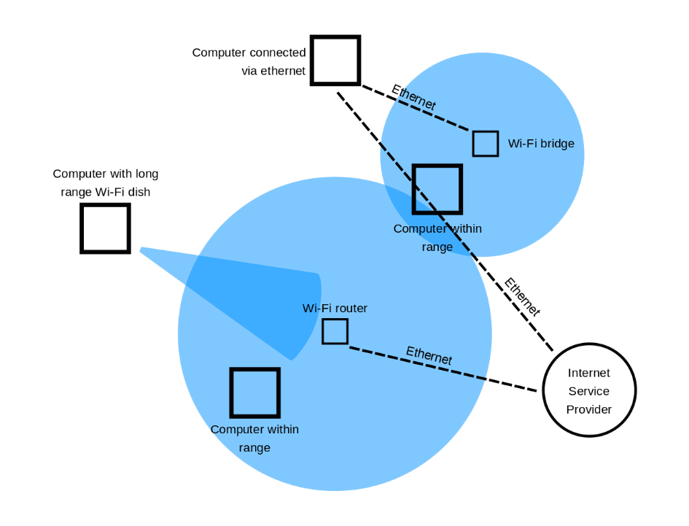

Schematic View

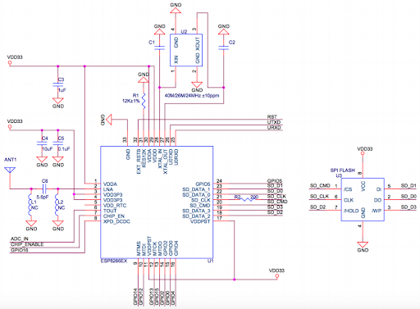

**2) Bluetooth**

**Bluetooth** is a wireless technology standard used for exchanging data between fixed and mobile devices over short distances using short-wavelength UHF radio waves in the industrial, scientific and medical radio bands, from 2.402 GHz to 2.480 GHz, and building personal area networks (PANs). It was originally conceived as a wireless alternative to RS-232 data cables.[27]

Specifications

Range

|  |  |
| --- | --- |
| **Class** | **Typ. range**[[2]](https://en.wikipedia.org/wiki/Bluetooth#cite_note-bluetooth1-2) **(m)** |
|
| **1** | ~100 |
| **1.5** (BT 5 Vol 6 Part A Sect 3) | ~20 |
| **2** | ~10 |
| **3** | ~1 |
| **4** | ~0.5 |

Modulation and Signalling

Based on the modulation scheme, multiple symbols may be used to represent a single bit, or a single symbol could potentially represent multiple bits. [26]

With BLE modulation specifically, a zero is coded to negative frequency deviation of at least 185kHz, and a 1 is coded to a positive frequency deviation of at least the same amount. At just the physical layer, BLE is capable of transmitting 1 million symbols per second. This translates to 1 Mbps assuming an encoding of 1 bit per symbol (which is standard for BLE). This threshold in the symbol rate is due to a limitation caused by intersymbol interference. Also, this is an idealized value that doesn’t take into account factors such as packet overhead. [26]

Scalability

To enable data exchange, modern devices such as smartphones, tablets, laptops, and desktop computers can be integrated into a network. This can be wired in the form of a Personal Area Network (PAN). The wireless variety is known as Wireless Personal Area Network (WPAN) and is based on technologies such as Bluetooth, Wireless USB, Insteon, IrDA, ZigBee, and Z-Wave. A wireless Personal Area Network, which can be achieved via Bluetooth, is called Piconet. PANs and WPANs usually only stretch over a few meters, and are therefore not suitable for connecting devices in different rooms or even buildings. [47]

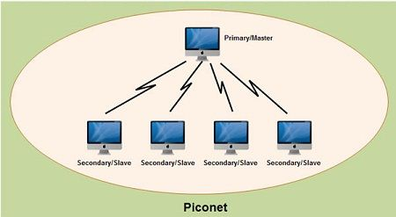

Schematic Diagram

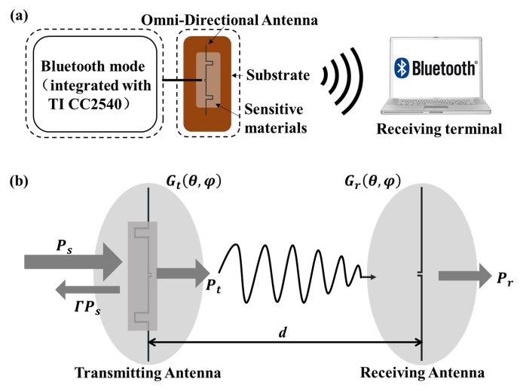

**3) Z-Wave**

Z-Wave is awireless communications protocol used primarily for home automation. It is a mesh network using low-energy radio waves to communicate from appliance to appliance, allowing for wireless control of residential appliances and other devices, such as lighting control, security systems, thermostats, windows, locks, swimming pools and garage door openers. Like other protocols and systems aimed at the home and office automation market, a Z-Wave system can be controlled via the Internet from a smart phone, tablet or computer, and locally through a smart speaker, wireless keyfob, or wall-mounted panel with a Z-Wave gateway. [44]

Specifications

Range

Z-Wave has a range of 100 meters or 328 feet in open air, building materials reduce that range. The more line powered devices in your Z-Wave network, the better, as they also act as repeaters to extend the Z-Wave signal. Z-Wave’s mesh networking allows a Z-Wave signal to “hop” through other Z-Wave products to reach the destination device to be controlled. Z-Wave supports up to 4 hops so the total home coverage will grow depending on the amount of Z-Wave products in the network. The maximum range with 4 hops is roughly 600 feet or 200 meters.

Modulation

|  |  |  |  |  |
| --- | --- | --- | --- | --- |
| **Data Rate Designation** | **Modulation** | **Coding** | **separation** | **Symbols** |
| R1 | FSK | Manchester | 40 KHz+/-10% | Binary |
| R2 | FSK | NRZ | 40 KHz+/-10% | Binary |
| R3 | GFSK (BT=0.6) | NRZ | 58 KHz+/-10% | Binary |

Signalling

It operates at 868.42 MHz in Europe, at 908.42 MHz in the North America and uses other frequencies in other countries depending on their regulations. Data rates include 9600 bps and 40 kbps, with output power at 1 mW.

Scalability

Z-Wave can be used within a network (Home Area Network, HAN), and can, therefore, be used to set up all areas of home automation, possibly controlled by a single controller. A mesh topology allows any node to connect to any other node and allows multiple connections.

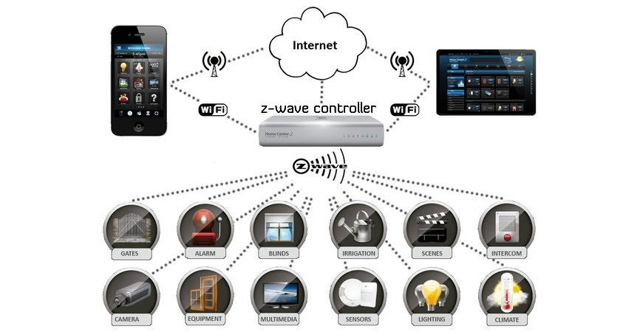

Schematic View

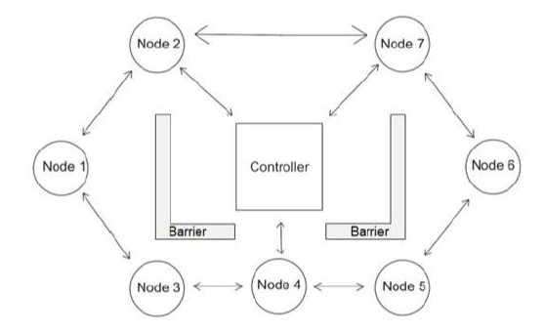

**4) LTE**

In telecommunications, Long-Term Evolution (LTE) is a standard for wireless broadband communication for mobile devices and data terminals, based on the GSM/EDGE and UMTS/HSPA technologies. It increases the capacity and speed using a different radio interface together with core network improvements. LTE is the upgrade path for carriers with both GSM/UMTS networks and CDMA2000 networks. The different LTE frequencies and bands used in different countries mean that only multi-band phones are able to use LTE in all countries where it is supported.[30]

Specifications

Range

LTE is required to support communication with terminals moving at speeds of up to 350 km/h, or even up to 500 km/h depending on the frequency band. The primary scenario for operation at such high speeds is usage on high-speed trains – a scenario which is increasing in importance across the world as the number of high-speed rail lines increases and train operators aim to offer an attractive working environment to their passengers. These requirements mean that handover between cells has to be possible without interruption – in other words, with imperceptible delay and packet loss for voice calls, and with reliable transmission for data services. These targets are to be achieved by the LTE system in typical cells of radius up to 5 km, while operation should continue to be possible for cell ranges of 100km and more, to enable wide-area deployments.[31]

Modulation

LTE is based on Orthogonal Frequency Division Multiple Access (OFDM), and achieves high data rates by combining large bandwidths, higher order modulation and spatial multiplexing. There are multi path fading problems in UMTS so LTE uses OFDM in the downlink to overcome such problems.[32]

Orthogonal frequency-division multiplexing (OFDM) is a method for encoding digital data transmission which uses a large number of closely spaced carriers that are modulated with low rate data stream. By making the signal orthogonal to each other, the signals would not interfere with other signals and thus mutual interference is avoided. By carrying the data at a lower rate across all carriers, the effects of reflections and inter-symbol interference are also overcome. If some of the carriers are lost due to multi-path effects, then the data can be reconstructed by using error correction techniques.[32]

Signalling

The LTE specification provides downlink peak rates of 300 Mbit/s, uplink peak rates of 75 Mbit/s and QoS provisions permitting a transfer latency of less than 5 ms in the radio access network. LTE has the ability to manage fast-moving mobiles and supports multi-cast and broadcast streams. LTE supports scalable carrier bandwidths, from 1.4 MHz to 20 MHz and supports both frequency division duplexing (FDD) and time-division duplexing (TDD). The IP-based network architecture, called the Evolved Packet Core (EPC) designed to replace the GPRS Core Network, supports seamless handovers for both voice and data to cell towers with older network technology such as GSM, UMTS and CDMA2000.[21] The simpler architecture results in lower operating costs (for example, each E-UTRA cell will support up to four times the data and voice capacity supported by HSPA[22]).

Frequencies used for LTE-TDD range from 1850 MHz to 3800 MHz, with several different bands being used.[30]

Scalability

**Wireless wide area network** (**WWAN**), is a form of wireless network. The larger size of a wide area network compared to a local area network requires differences in technology. Wireless networks of different sizes deliver data in the form of telephone calls, web pages, and streaming video.[33]

A WWAN often differs from wireless local area network (WLAN) by using mobile telecommunication cellular network technologies such as 3G, 4G LTE, and 5G to transfer data. These technologies are offered regionally, nationwide, or even globally and are provided by a wireless service provider. WWAN connectivity allows a user with a laptop and a WWAN card to surf the web, check email, or connect to a virtual private network (VPN) from anywhere within the regional boundaries of cellular service. Various computers can have integrated WWAN capabilities.[33]

A WWAN may also be a closed network that covers a large geographic area. For example, a mesh network or MANET with nodes on buildings, towers, trucks, and planes could also be considered a WWAN.[33]

A WWAN may also be a low-power, low-bit-rate wireless WAN, (LPWAN), intended to carry small packets of information between things, often in the form of battery-operated sensors.

Since radio communications systems do not provide a physically secure connection path, WWANs typically incorporate encryption and authentication methods to make them more secure. Some of the early GSM encryption techniques were flawed, and security experts have issued warnings that cellular communication, including WWAN, is no longer secure. UMTS (3G) encryption was developed later and has yet to be broken.[33]

Schematic Diagram

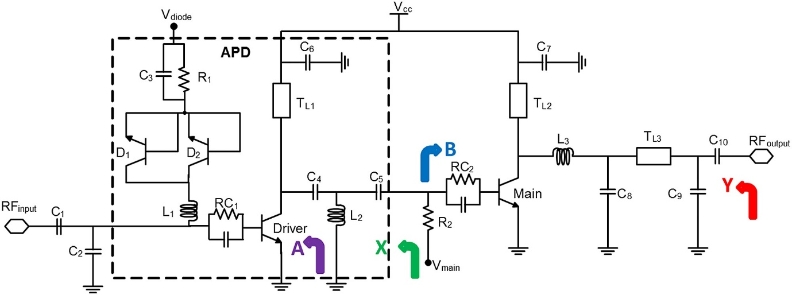

**5) WiMAX**

WiMAX (Worldwide Interoperability for Microwave Access) is a family of wireless broadband communication standards based on the IEEE 802.16 set of standards, which provide multiple physical layer (PHY) and Media Access Control (MAC) options. [43]

The name "WiMAX" was created by the WiMAX Forum, which was formed in June 2001 to promote conformity and interoperability of the standard, including the definition of predefined system profiles for commercial vendors. The forum describes WiMAX as "a standards-based technology enabling the delivery of last mile wireless broadband access as an alternative to cable and DSL". IEEE 802.16m or WirelessMAN-Advanced was a candidate for the 4G, in competition with the LTE Advanced standard. [43]

Specifications

Range

WiMAX outdistances WiFi by miles. WiFi's range is about 100 feet (30 m). WiMAX will blanket a radius of **30 miles** (50 km) with wireless access. The increased range is due to the frequencies used and the power of the transmitter. Of course, at that distance, terrain, weather and large buildings will act to reduce the maximum range in some circumstances, but the potential is there to cover huge tracts of land. [34]

Modulation

WiMAX modulation and coding is adaptive, enabling it to vary these parameters according to prevailing conditions. WiMAX modulation and coding can be changed on a burst by burst basis per link. To determine the required WiMAX modulation and coding scheme the channel quality feedback indicator is used. The mobile can provide the base station with feedback on the downlink channel quality and for the uplink, the base station can estimate the channel quality, based on the received signal quality. [35]

| **PARAMETER** | **DOWNLINK** | **UPLINK** |
| --- | --- | --- |
| **Modulation** | BPSK, QPSK, 16 QAM, 64 QAM; BPSK optional for OFDMA-PHY | BPSK, QPSK, 16 QAM; 64 QAM optional |
| **Coding** | **Mandatory:** convolutional codes at rate 1/2, 2/3, 3/4, 5/6  **Optional:** convolutional turbo codes at rate 1/2, 2/3, 3/4, 5/6; repetition codes at rate 1/2, 1/3, 1/6, LDPC, RS-Codes for OFDM-PHY | **Mandatory:** convolutional codes at rate 1/2, 2/3, 3/4, 5/6  **Optional:** convolutional turbo codes at rate 1/2, 2/3, 3/4, 5/6; repetition codes at rate 1/2, 1/3, 1/6, LDPC |

Signalling

1. Speed - 70 megabits per second [34]
2. Line-of-sight not needed between user and base station [34]
3. Frequency bands - 2 to 11 GHz and 10 to 66 GHz (licensed and unlicensed bands) [34]

Scalability

WiMAX is the wireless solution for the next step up in scale, the metropolitan area network (MAN). A MAN allows areas the size of cities to be connected. WiMAX provides metropolitan area network (MAN) connectivity at speeds of up to 75 Mb/sec. WiMAX systems can be used to transmit signal as far as 30 miles. As WiMax can support data ranges across miles, it is well suited for a country such as India where telecom infrastructure is poor and last mile access is expensive. This ability lets ISPs players offer broadband access directly to homes without worrying about the problems of installing the last mile through optic fibre or cables. WiMax is also a big boon for telecom companies as it enables these companies to serve customers in rural areas without spending billions installing expensive infrastructure for minimal returns. [34]

Schematic Diagram

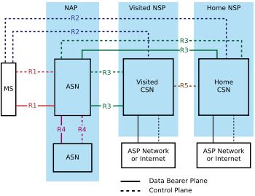

**6) Zigbee**

Zigbee is a wireless technology developed as an open global standard to address the unique needs of low-cost, low-power wireless IoT networks. The Zigbee standard operates on the IEEE 802.15. 4 physical radio specification and operates in unlicensed bands including 2.4 GHz, 900 MHz and 868 MHz. [41]

Specifications

1. Range

Its low power consumption limits transmission distances to 10–100 meters line-of-sight, depending on power output and environmental characteristics. Zigbee devices can transmit data over long distances by passing data through a mesh network of intermediate devices to reach more distant ones. Data range is 250 kbps and the number of nodes that can be connected are around 64,000. [42]

1. Modulation

Zigbee modulation is carried out through direct sequence spread spectrum (DSSS). The 2.4 GHz band, in which ZigBee transceivers are most commonly deployed, uses the OQPSK (offset quadrature phase-shift keying) modulation stream. [37]

Scalability

The Zigbee network specification states that networks can theoretically scale to thousands of nodes per network. However, realistically, and in practice, Zigbee networks can scale to hundreds of nodes in a single network. [38]

Schematic Diagram

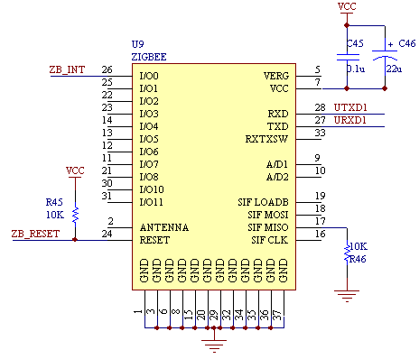

**7) Starlink**

Starlink is a satellite constellation development project underway by SpaceX, to develop a low-cost, high-performance satellite bus and requisite customer ground transceivers to implement a new spaceborne Internet communication system. The constellation will consist of thousands of mass-produced small satellites in low Earth orbit (LEO), working in combination with ground transceivers. [51]

Product development began in 2015, with the first two prototype test-flight satellites launched in February 2018. A second set of test satellites and the first large deployment of a piece of the constellation occurred in May 2019 when the first 60 operational satellites were launched. The first 60 Starlink satellites were launched on May 23, 2019, aboard a SpaceX Falcon 9 rocket. The satellites successfully reached their operational altitude of 340 miles (550 kilometers) — low enough to get pulled down to Earth by atmospheric drag in a few years so that they don't become space junk once they die.  As of 2020, SpaceX is launching 60 satellites at a time, aiming to deploy 1,584 of the 260 kilograms (570 lb) spacecraft to provide near-global service by late 2021 or 2022. SpaceX is targeting a private beta service in the Northern United States and Canada by August 2020 with a public beta following in November 2020, service beginning at high latitudes between 44°-52° North. [51]

**How Starlink internet will work**

* Starlink satellites will sit closer to the Earth to reduce latency and use lasers to boost internet speeds. [52]
* Starlink satellites will sit about 342 miles above the Earth’s surface. That’s much closer than other satellites, which means there’s much less distance for your internet signal to travel to a Starlink satellite. [52]
* Each Starlink satellite will communicate with four other satellites using lasers. That means they’ll beam data across the globe at almost the speed of light—a speed that only fiber-optic internet comes close to matching. [52]

How fast Starlink internet will be

According to SpaceX, Starlink will offer speeds of up to a gigabit per second at latencies from 25 milliseconds to 35 milliseconds. [53]

Those latencies would make SpaceX's service comparable to cable and fiber, while existing satellite broadband services have latencies of 600 ms or more, according to FCC measurements.

Keeping space clean

In a filing to the Federal Communications Commission (FCC), SpaceX is asking the agency to modify its license so that more than 1,500 Starlink satellites can operate at an altitude 600 kilometers lower than the company originally requested. [54]

SpaceX says moving the satellites to a lower altitude means it can do more with less.

Lower altitude makes it easy to dispose of these satellites once they’re done in space. At this height, particles from Earth’s atmosphere bombard the spacecraft more rapidly, pushing them out of orbit and dragging them down to the planet. And on the way down, they burn up in the atmosphere. [54]

Making sure these spacecraft come out of orbit in a timely manner is crucial because of the vast number of vehicles that SpaceX wants to put into orbit. A constellation the size of Starlink could dramatically increase the number of operational satellites in space, raising the risk of in-space collisions. A recent NASA study argued that 99 percent of these satellites will need to be taken out of orbit, reliably, within five years of launch, or the risk of satellite collisions goes up quite a bit. [54]

The atmosphere at 550 kilometers should do the job within a few years. This is helpful in case the spacecraft fails in orbit. Satellites that fail in higher altitudes could turn into unoperational space debris that stay in orbit for long periods of time. At lower altitudes, they can still fail, and the atmosphere will still swallow them up in a timely manner. [54]

**References**

[1] Data Communication and Networking, 5th Edition by Behrouz A. Forouzan

[2] <https://en.wikipedia.org/wiki/Physical_layer>

[3] <https://en.wikipedia.org/wiki/Transmission_medium>

[4] <https://www.javatpoint.com/transmission-media>

[5] <https://www.studytonight.com/computer-networks/transmission-mediums>

[6] <https://www.slideshare.net/MukeshChinta/physical-layer-osi-model>

[7] <https://www.studytonight.com/computer-networks/bounded-transmission-media>

[8] <https://www.ciscopress.com/articles/article.asp?p=31276>

[9] <http://vclab.tu-sofia.bg/AVC%20Network%20Lessons/MCSE-NE/5a6b40b.htm>

[10] <https://en.wikipedia.org/wiki/Twisted_pair>

[11] <https://en.wikipedia.org/wiki/Coaxial_cable>

[12] <http://piot.nedly.apom.orsal.cette.mohammedshrine.org/schematic-diagram-of-bnc-connector-parts-and-components-1-connector.html>

[13] <https://www.thefoa.org/tech/ref/basic/fiber.html>

[14] [https://www.ecn.co.za/pros-cons fibre/#:~:text=Scalability&text=Fibre%20optics%20are%20much%20more,laid%20at%20a%20later%20stage.](https://www.ecn.co.za/pros-cons%20fibre/#:~:text=Scalability&text=Fibre%20optics%20are%20much%20more,laid%20at%20a%20later%20stage.)

[15] <https://www.tutorialspoint.com/fiber-distributed-data-interface-fddi>

[16] <http://sup.xenya.si/sup/info/digital/MDS/jun99/Cd2/NETWORK/DFDDICG1.PDF>

[17] <https://www.southampton.ac.uk/~sqc/EL336/CNL-3.pdf>

[18] <https://en.wikipedia.org/wiki/Fiber_Distributed_Data_Interface>

[19] <https://simple.wikipedia.org/wiki/Ethernet>

[20] <https://en.wikipedia.org/wiki/Ethernet>

[21] <http://units.folder101.com/cisco/sem1/Notes/ch7-technologies/encoding.htm#manchester>

[22] <https://www.edn.com/pam-ethernet-a-perfect-match/>

[23] <https://pdfs.semanticscholar.org/9717/5d7133a228b109aa881d3cb7228c80454677.pdf>

[24] <https://www.lifewire.com/range-of-typical-wifi-network-816564>

[25] <https://en.wikipedia.org/wiki/Wireless_LAN>

[26] <https://punchthrough.com/crash-course-in-2m-bluetooth-low-energy-phy/>

[27] <https://en.wikipedia.org/wiki/Bluetooth>

[28] <https://www.rfwireless-world.com/Tutorials/z-wave-physical-layer.html>

[29] <https://www.z-wave.com/faq>

[30] <https://en.wikipedia.org/wiki/LTE_(telecommunication)>

[31] <https://www.slideshare.net/yihsuehtsai/long-range-cell-coverage-for-lte#:~:text=2.,depending%20on%20the%20frequency%20band>

[32] <https://www.4gmobiletech.com/modulation-techniques>

[33] <https://en.wikipedia.org/wiki/Wireless_WAN>

[34] <https://computer.howstuffworks.com/wimax.htm>

[35] <https://www.electronics-notes.com/articles/connectivity/wimax/rf-interface-physical-layer.php>

[36] <http://www.tmcnet.com/channels/wimax/what-is-wimax.aspx#:~:text=WiMAX%20provides%20metropolitan%20area%20network,as%20far%20as%2030%20miles.&text=As%20WiMax%20can%20support%20data,last%20mile%20access%20is%20expensive>

[37] <https://www.link-labs.com/blog/z-wave-vs-zigbee>

[38] <http://radar.oreilly.com/2014/08/how-to-identify-a-scalable-iot-network-topology.html>

[39] <https://quizlet.com/123650851/understanding-local-area-network-flash-cards/>

[40] <https://en.wikipedia.org/wiki/Wireless_network>

[41] <https://www.digi.com/solutions/by-technology/zigbee-wireless-standard>

[42] <https://en.wikipedia.org/wiki/Zigbee>

[43] <https://en.wikipedia.org/wiki/WiMAX>

[44] <https://en.wikipedia.org/wiki/Z-Wave>

[45] <https://en.wikipedia.org/wiki/Wi-Fi>

[46]<https://documentation.meraki.com/MR/WiFi_Basics_and_Best_Practices/802.11_fundamentals%3A_Modulation>

[47] <https://www.ionos.com/digitalguide/server/know-how/the-different-network-types/>

[48] <https://en.wikipedia.org/wiki/USB>

[49] <https://pc4u.org/usb-3-2-simplicity-scalability/>

[50] [https://www.synopsys.com/designware-ip/technical-bulletin/protocol-layer changes.html](https://www.synopsys.com/designware-ip/technical-bulletin/protocol-layer%20changes.html)

[51] <https://www.space.com/spacex-starlink-satellites.html>

[52] <https://en.wikipedia.org/wiki/Starlink>

[53] <https://directory.eoportal.org/web/eoportal/satellite-missions/s/starlink>

[54] <https://www.reviews.org/internet-service/spacex-starlink-satellite-internet-review>/